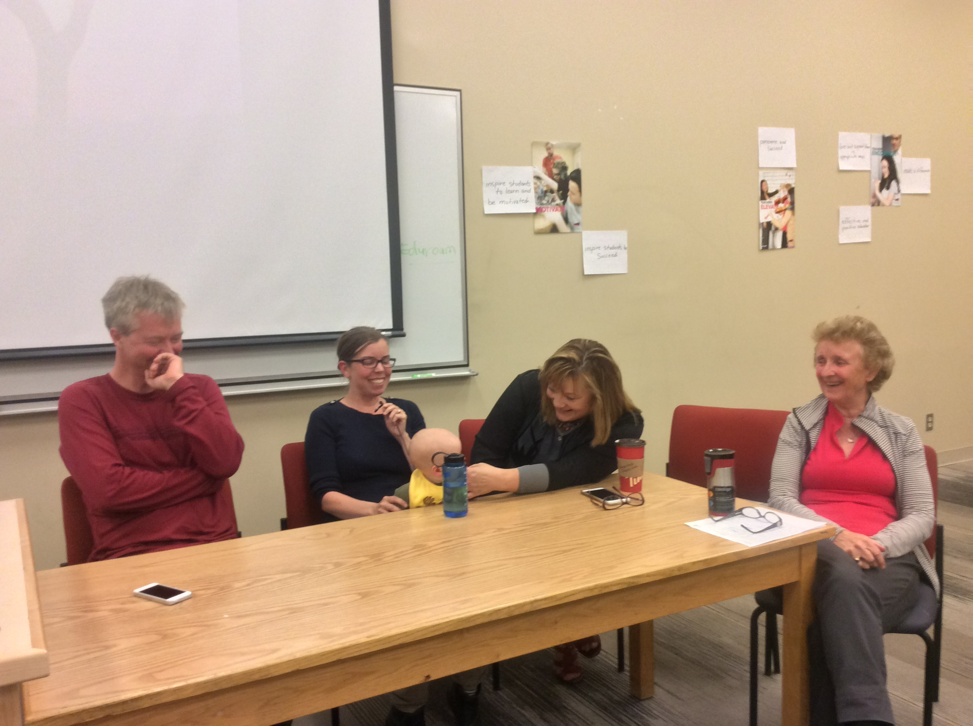

Monday OCTOBER 26 2015

*All About* STEMinism

York University Libraries

Faculty of Science

Lassonde School of Engineering

School of Gender, Sexuality and Women's Studies

Science and Technology Studies

Politics of Evidence Working Group, Robarts Centre

<http://bit.ly/1P0bAVV>

# A talk by Dean Imogen Coe, Faculty of Science, Ryerson University

# Monday October 26, 1:30-2:30pm

Bergeron Centre for Engineering Excellence, 217

Keele Campus

# Ada Lovelace Day Wikipedia Edit-A-Thon

# Thursday October 29, 10am-5pm

Steacie Science & Engineering Library

Room 021, basement via the Library

Keele Campus

Join an interdisciplinary team of faculty and students as we create, expand and improve Wikipedia entries for **Women in STEM (Science, Technology, Engineering & Mathematics)**. STEM Women are under-represented in Wikipedia.

Learn how to be a Wikipedian. Drop by for as long or short a time as you have available. We will have swag & snacks for you.

Professor Imogen Coe is founding Dean of Science at Ryerson University. She was previously the chair of Biology at York University. Her research is in membrane protein cell biology and biochemistry.

Imogen is a strong voice for women in **STEM**. She blogs at Huffington Post Canada on this topic. She will be discussing ongoing challenges to increasing the percentage of women in **Science, Technology, Engineering and Mathematics**, and why we must all learn to be STEMinists, as we celebrate Ada Lovelace Day 2015.